**Q.1. Display first 5 rows of dataset**

**=>** ds.head()

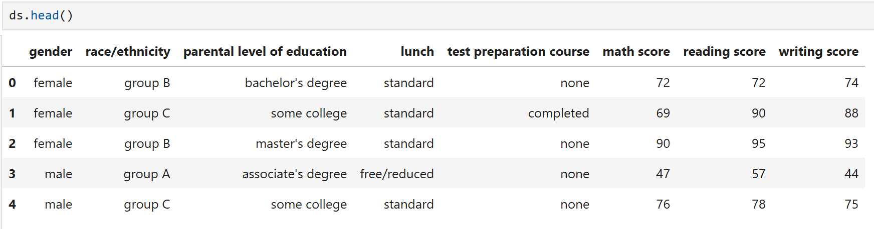

**Q.2. Display the last 5 rows of dataset**

**=>** ds.tail()

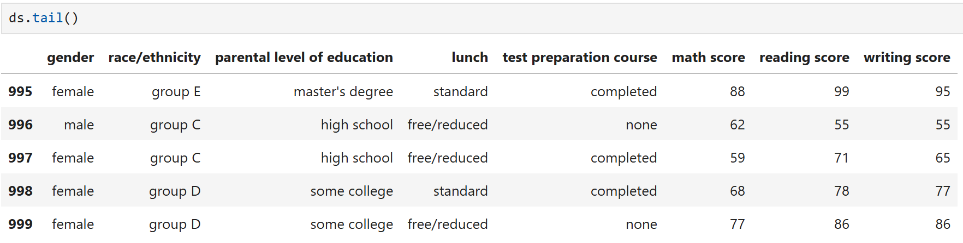

**Q.3. What is the shape of the DataSet (number of rows and columns)?**

**=>** ds.shape

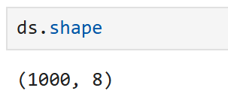

**Q.4. Display summary information about the DataSet, including data types and non-null counts.**

**=>** ds.info()

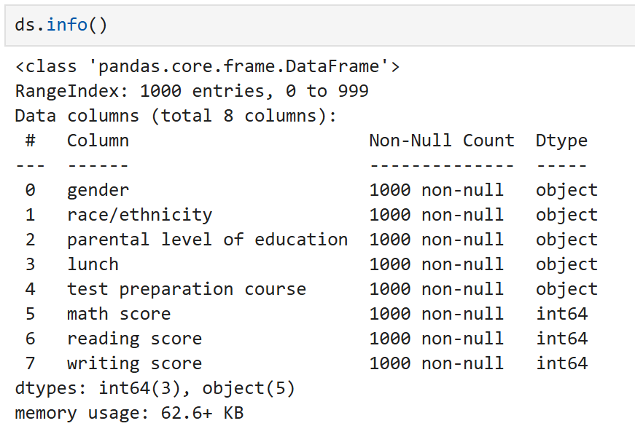

**Q.5. Get descriptive statistics for numerical columns in the DataSet.**

**=>** ds.describe()

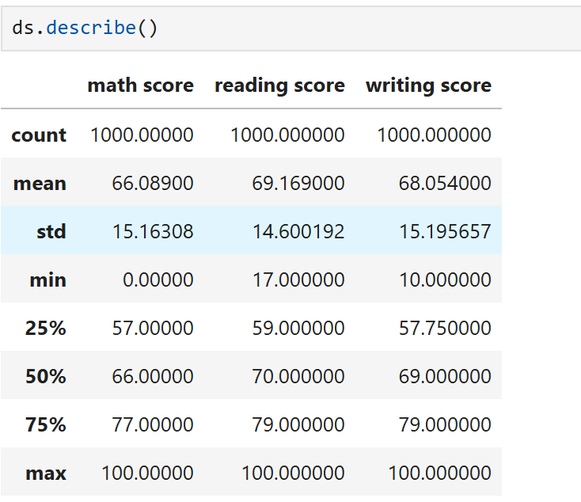

**Q.6. Select the "gender" column from the DataSet.**

**=>** ds['gender']

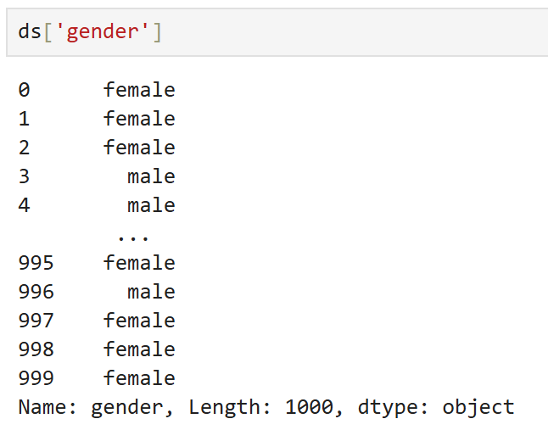

**Q.7. Select the "gender" and "race/ethnicity" columns from the DataSet.**

**=>** ds[['gender','race/ethnicity']]

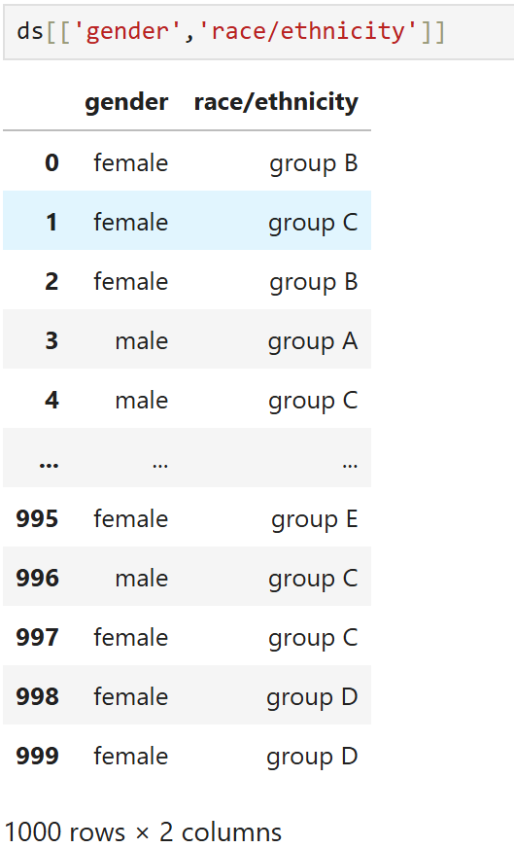

**Q.8. Select the first row from the DataSet by index.**

**=>** ds.iloc[0]

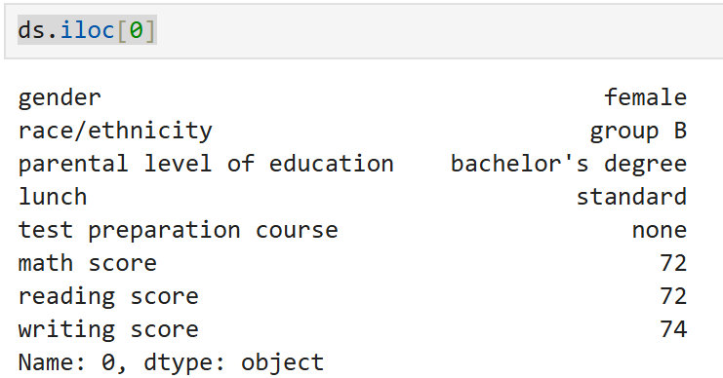

**Q.9. Select the row with label/index 0 from the DataSet.**

**=>** ds.loc[0]

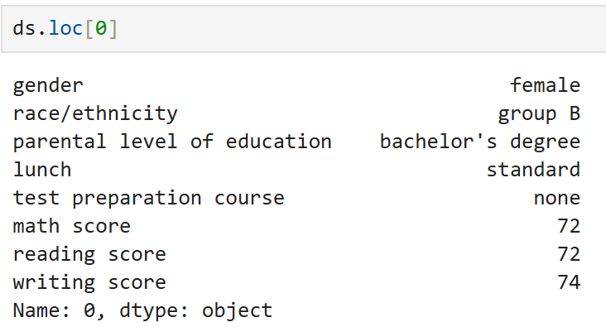

**Q.10. Select rows from 1 to 5 and columns from 2 to 3**

**=>** ds.iloc[1:5, 2:4]

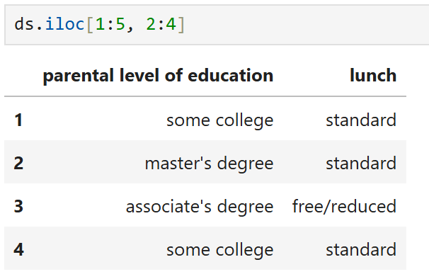

**Q.11. Filter the DataSet for rows where "math score" is greater than 90.**

**=>** ds[ds['math score']>90]

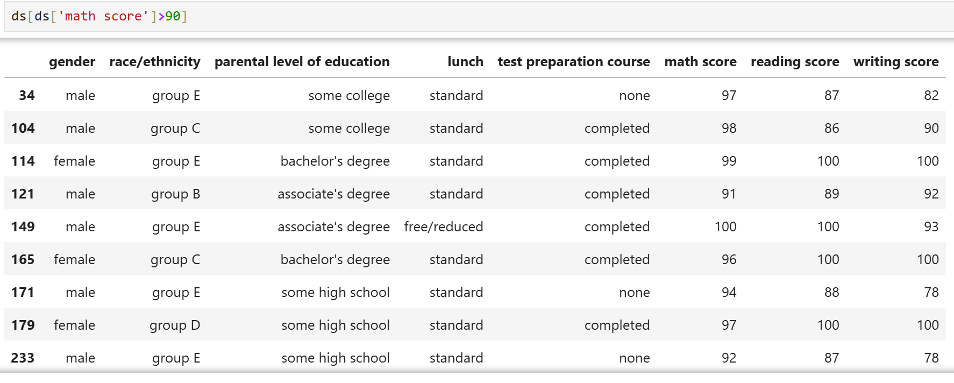

**Q.12. Use the query method to filter rows where "math score" is greater than 90.**

**=>** ds.query("`math score` > 90")

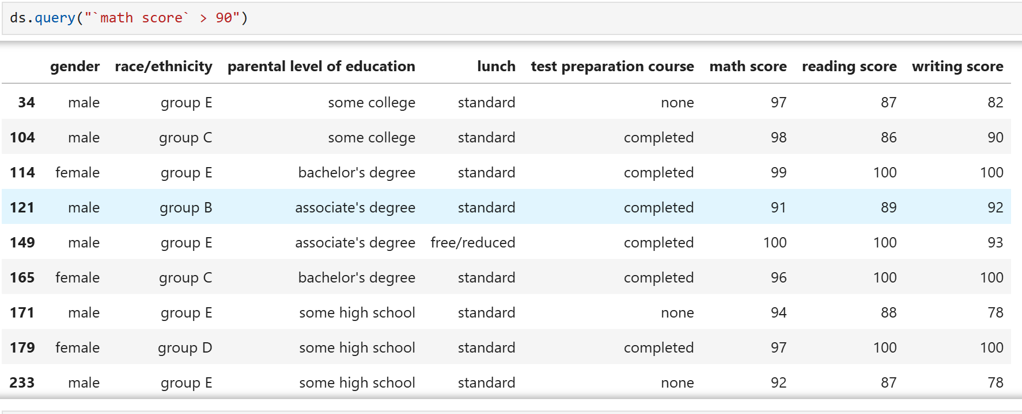

**Q.13. Sort the DataSet by the "math score" column in ascending order.**

**=>** ds.sort_values('math score')

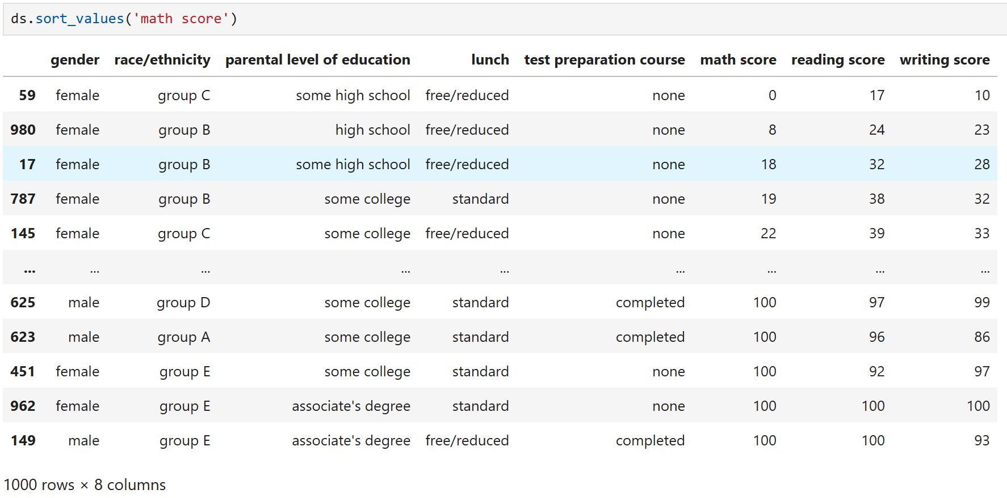

**Q.14. Check if there are any missing values in the DataSet.**

**=>** ds.isnull()

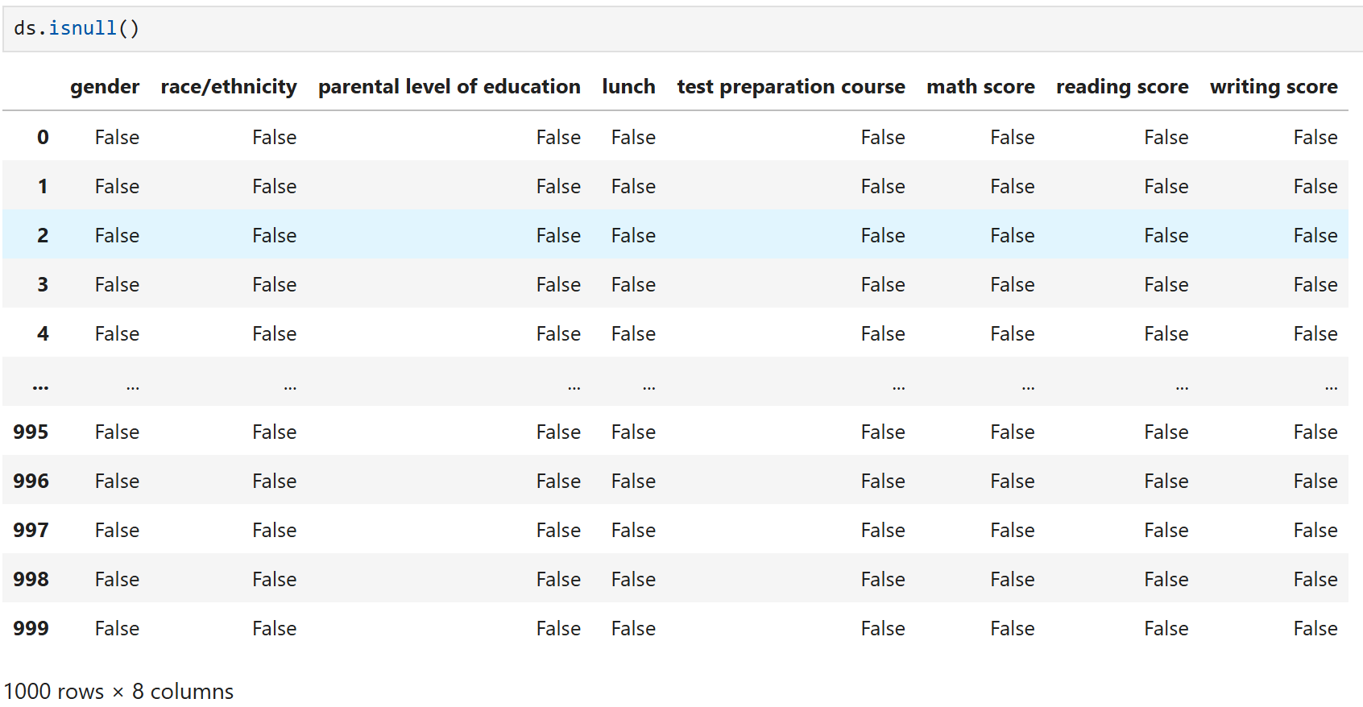

**Q.15. Count the number of missing values in each column.**

**=>** ds.isnull().sum()

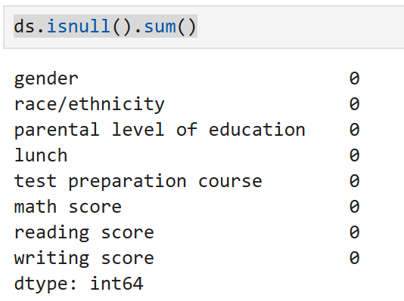

**Q.16. Fill missing values with 0.**

**=>** ds.fillna(0, inplace= True)

ds.isnull().sum()

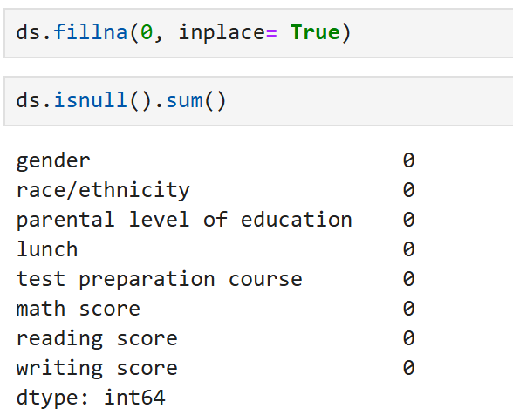

**Q.17. Sort the dataSet based on a specific column.**

**=>** ds.sort_values(by='math score', ascending=False)

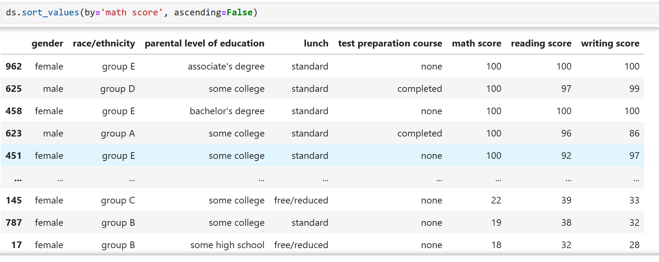

**Q.18. Filter rows where the lunch is of standard type.**

**=>** ds[ds['lunch']=='standard']

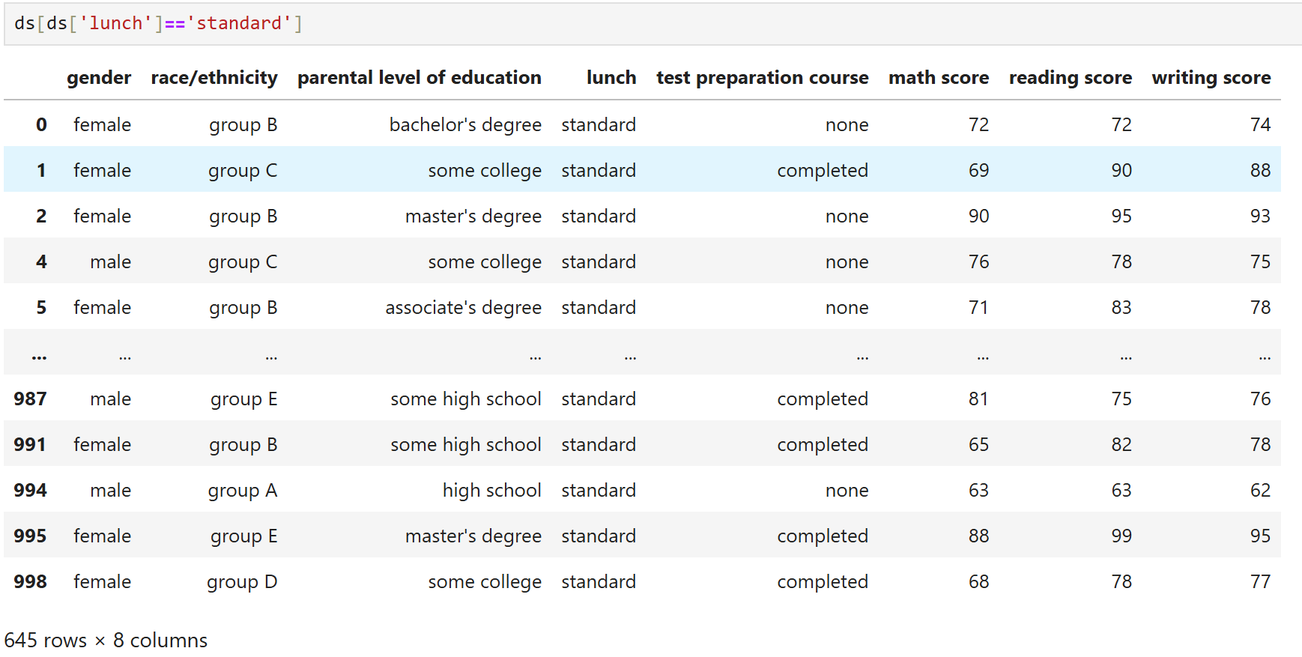

**Q.19. Convert 'male'/'female' responses to 'm'/'f'**

**=>** ds['gender'].map({'male':'m','female':'f'})

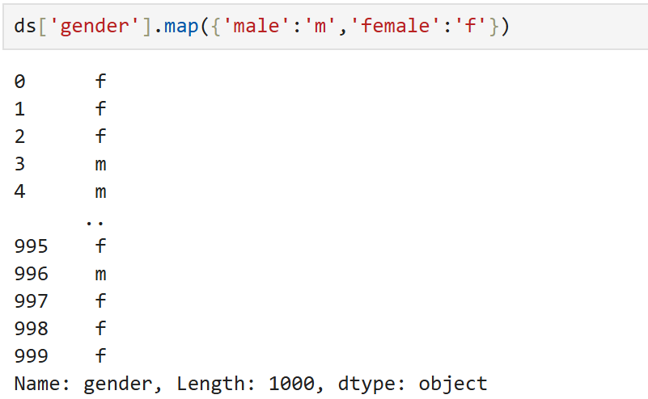

**Q.20. Selects the element in the first row and first column**

**=> ds.iloc[0, 0]**

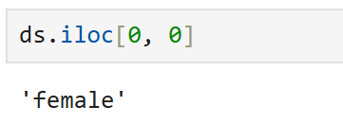

**Q.21. Find all rows where gender is "male" and race/ethnicity is “group B”**

**=>** ds[(ds['gender']=='male')&(ds['race/ethnicity']=='group B')]

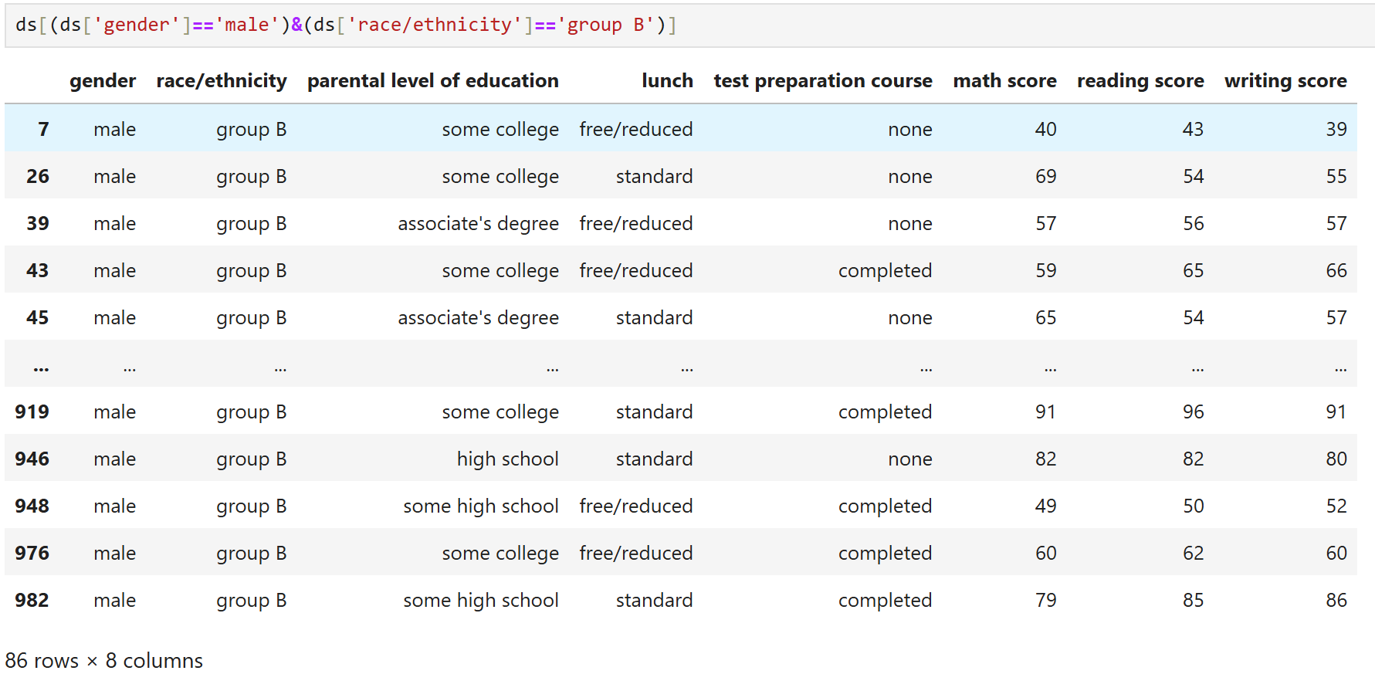

**Q.22. Find unique values in the 'parental level of education' column.**

**=>** ds['parental level of education'].unique()

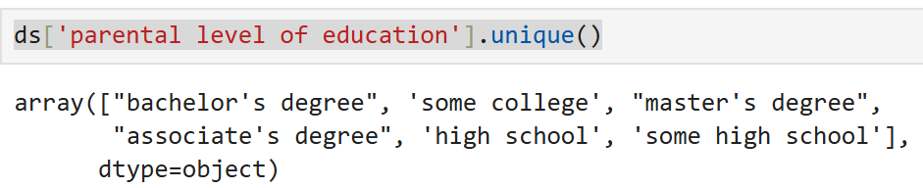

**Q.23. Count unique values in the 'parental level of education' column.**

**=>** ds['parental level of education'].nunique()

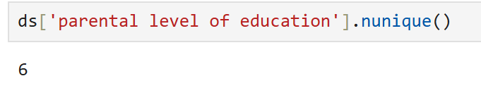

**Q.24. Calculate the average reading score.**

**=>** ds['reading score'].mean()

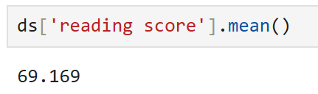

**Q.25. Select the first 3 rows of the 'test preparation course' and 'writing score' columns.**

**=>** ds.loc[:2,['test preparation course','writing score']]

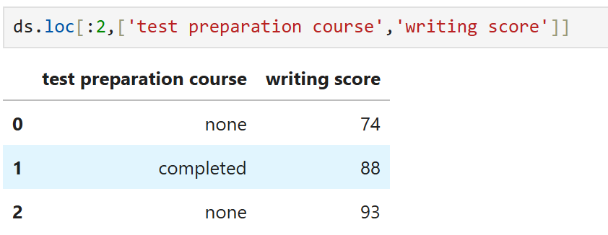

**Q.26. Select the first 3 rows of the 'reading score'.**

**=>** ds.loc[:2,['reading score']]

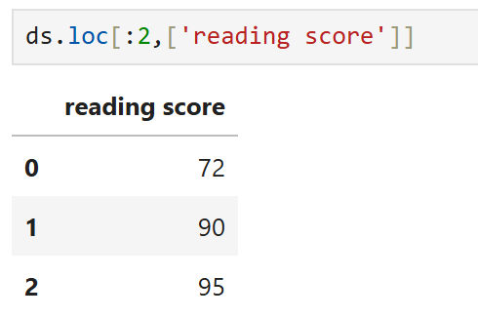

**Q.27. Change ‘test preparation course’ for the student with ‘writing score’ >=90 to "completed”.**

**=>** ds.loc[ds['writing score'] >=90, 'test preparation course'] = "completed"

print(ds.loc[ds['writing score'] >=90])

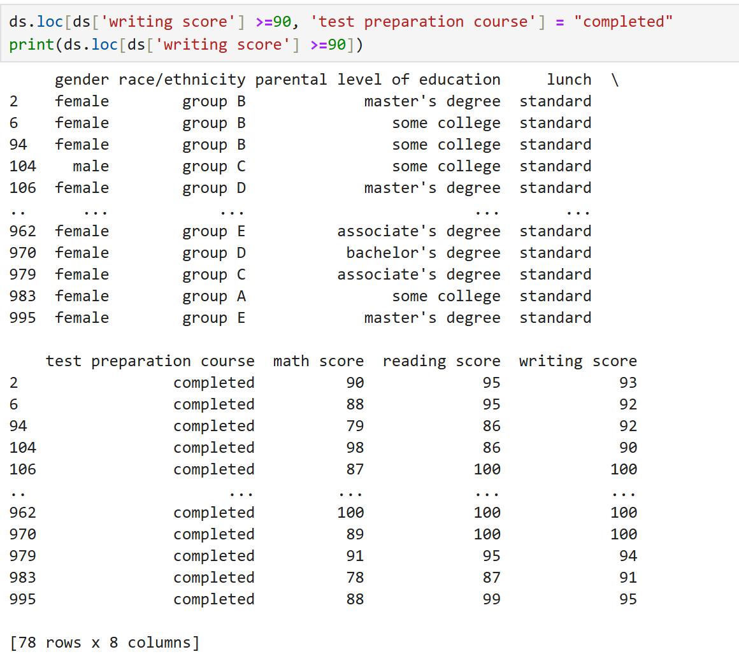

**Q.28. Check if 'race/ethnicity' == ‘group F’ exists**

**=>** if (ds['race/ethnicity'] == 'group F').any():

ds.loc[ds['race/ethnicity'] == 'group F', 'lunch'] = "standard"

print(ds.loc[ds['race/ethnicity'] == 'group F'])

else:

print("No row with race/ethnicity == group F found.")

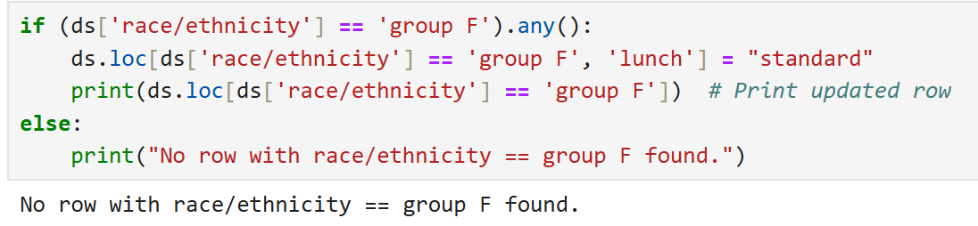

**Q.29.**

**=>** ds.iloc[[0,1]]

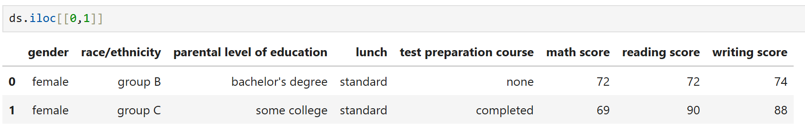

**Q.30.**

**=>** ds.iloc[[0,5],2]

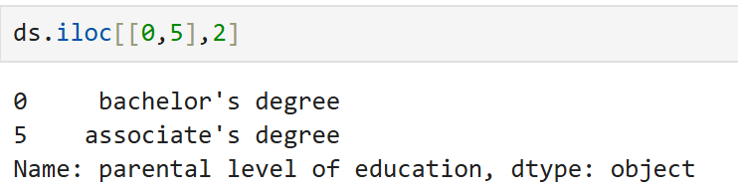

**Q.31.**

**=>** ds.loc[[0,5],['parental level of education','lunch']]

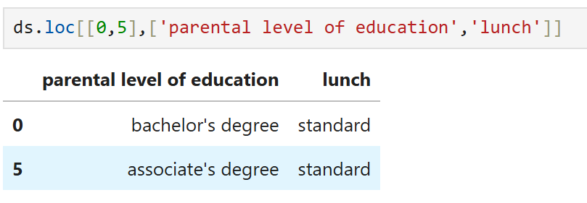

**Q.32.**

**=>** ds['lunch'].value_counts()

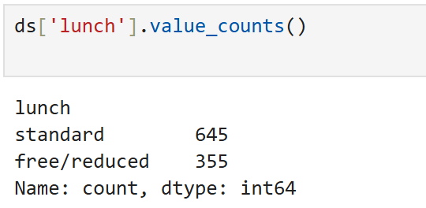

**Q.33.**

**=>** ds.loc[[1,4,7],['gender','test preparation course']]

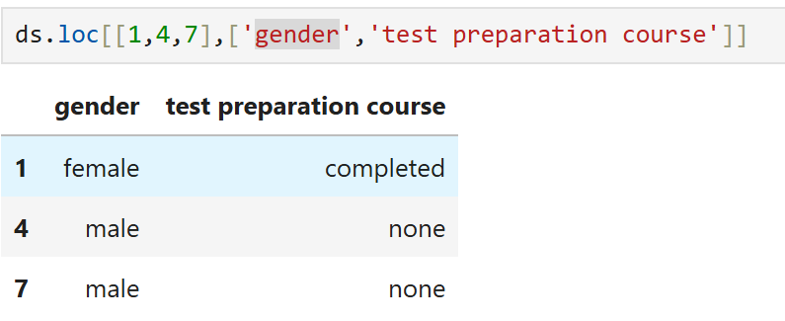

**Q.34.**

**=>** ds.loc[1:8,['gender','test preparation course']]

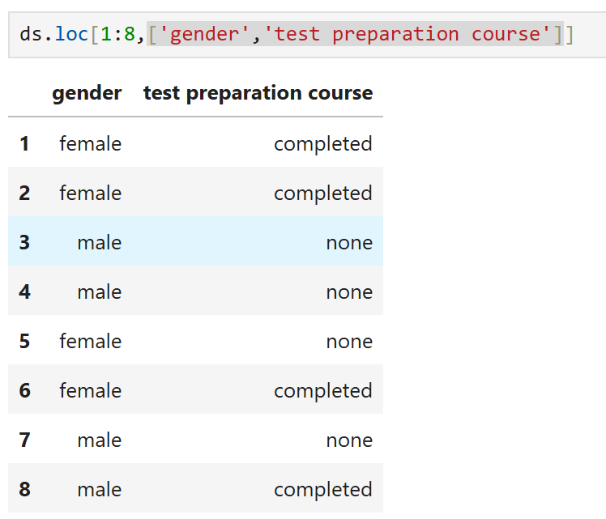

**Q.35.**

**=>** ds.loc[1:8:2,['gender','test preparation course']]

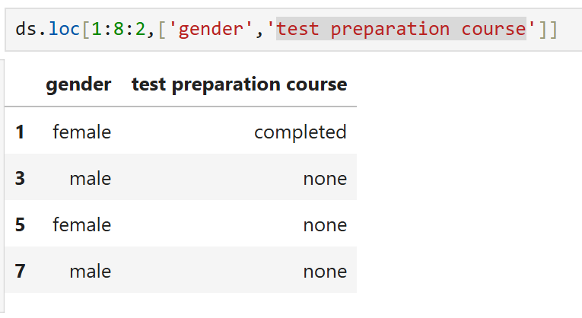

**Q.36.**

**=>** ds.loc[1:8:2,'gender':'test preparation course']

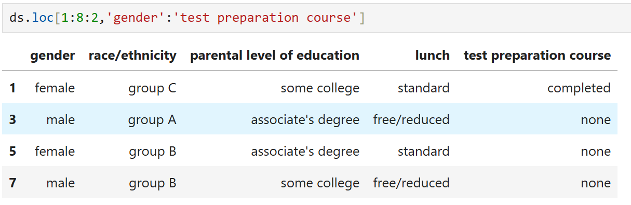

**Q.37.**

**=>** ds.set_index('parental level of education')

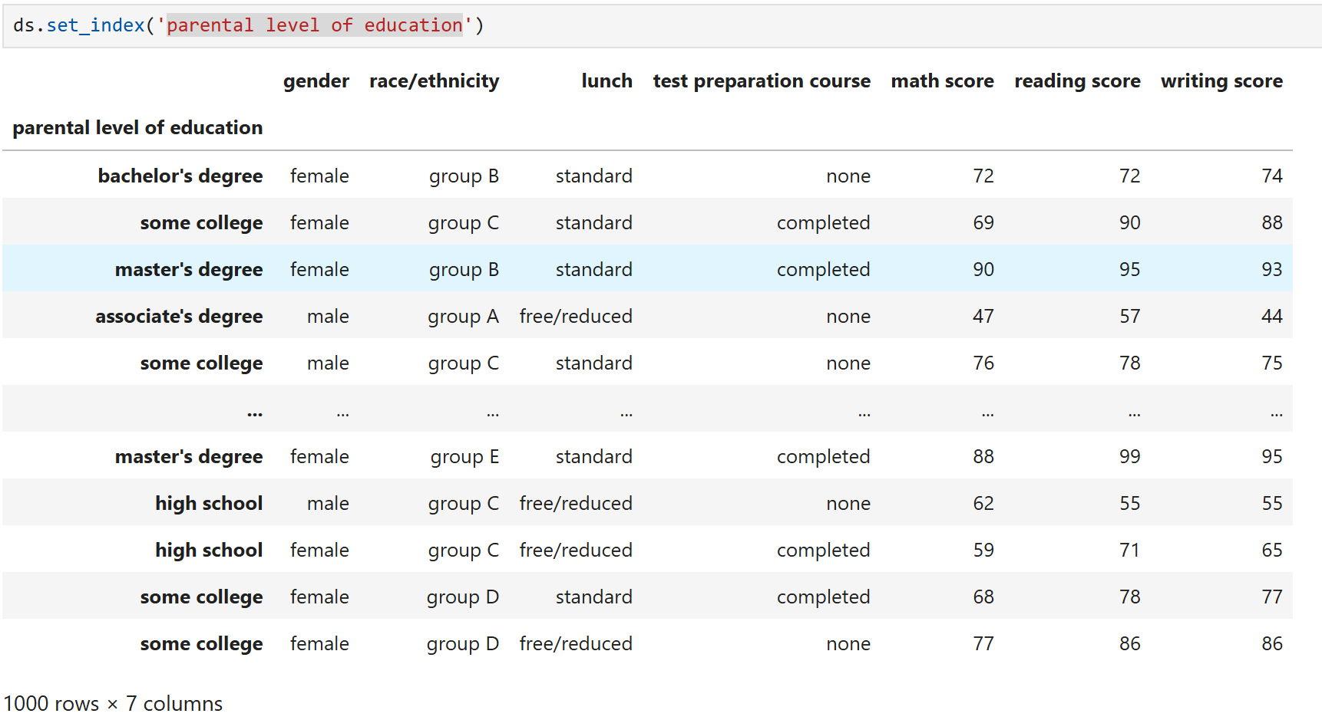

**Q.38.**

**=>** ds.set_index('gender',inplace=True)

ds.index

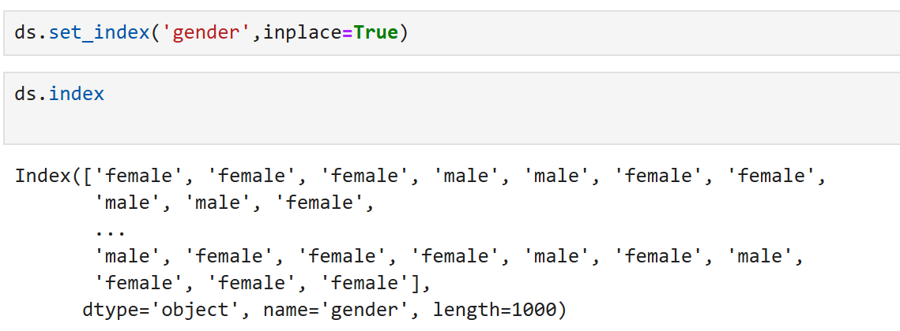

**Q.39.**

**=>** ds.reset_index(inplace=True)

ds.index

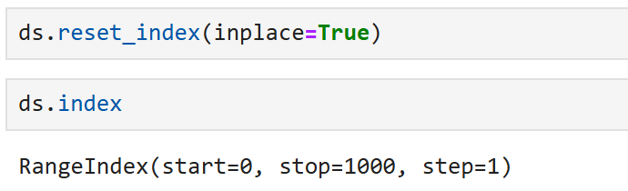

**Q.40.**

**=>** ds.loc[[2],['lunch','parental level of education']]

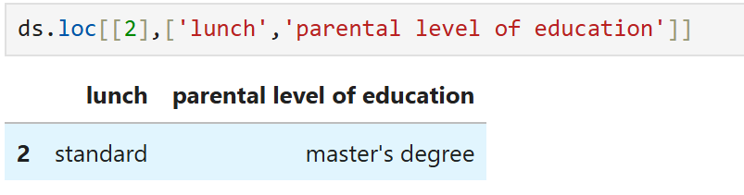

**Q.41.**

**=>** ds['gender']=='male'

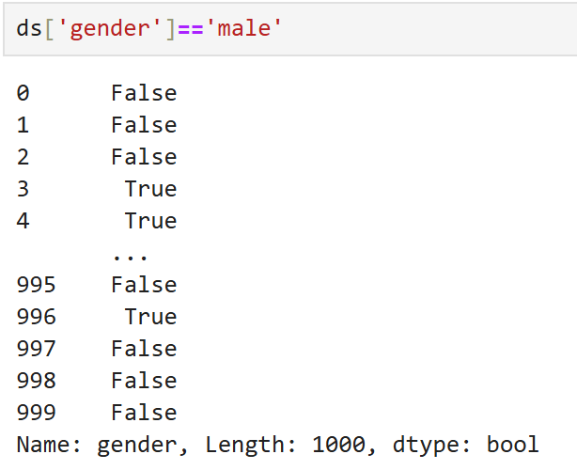

**Q.42.**

**=>** ds.query('gender == "male"')

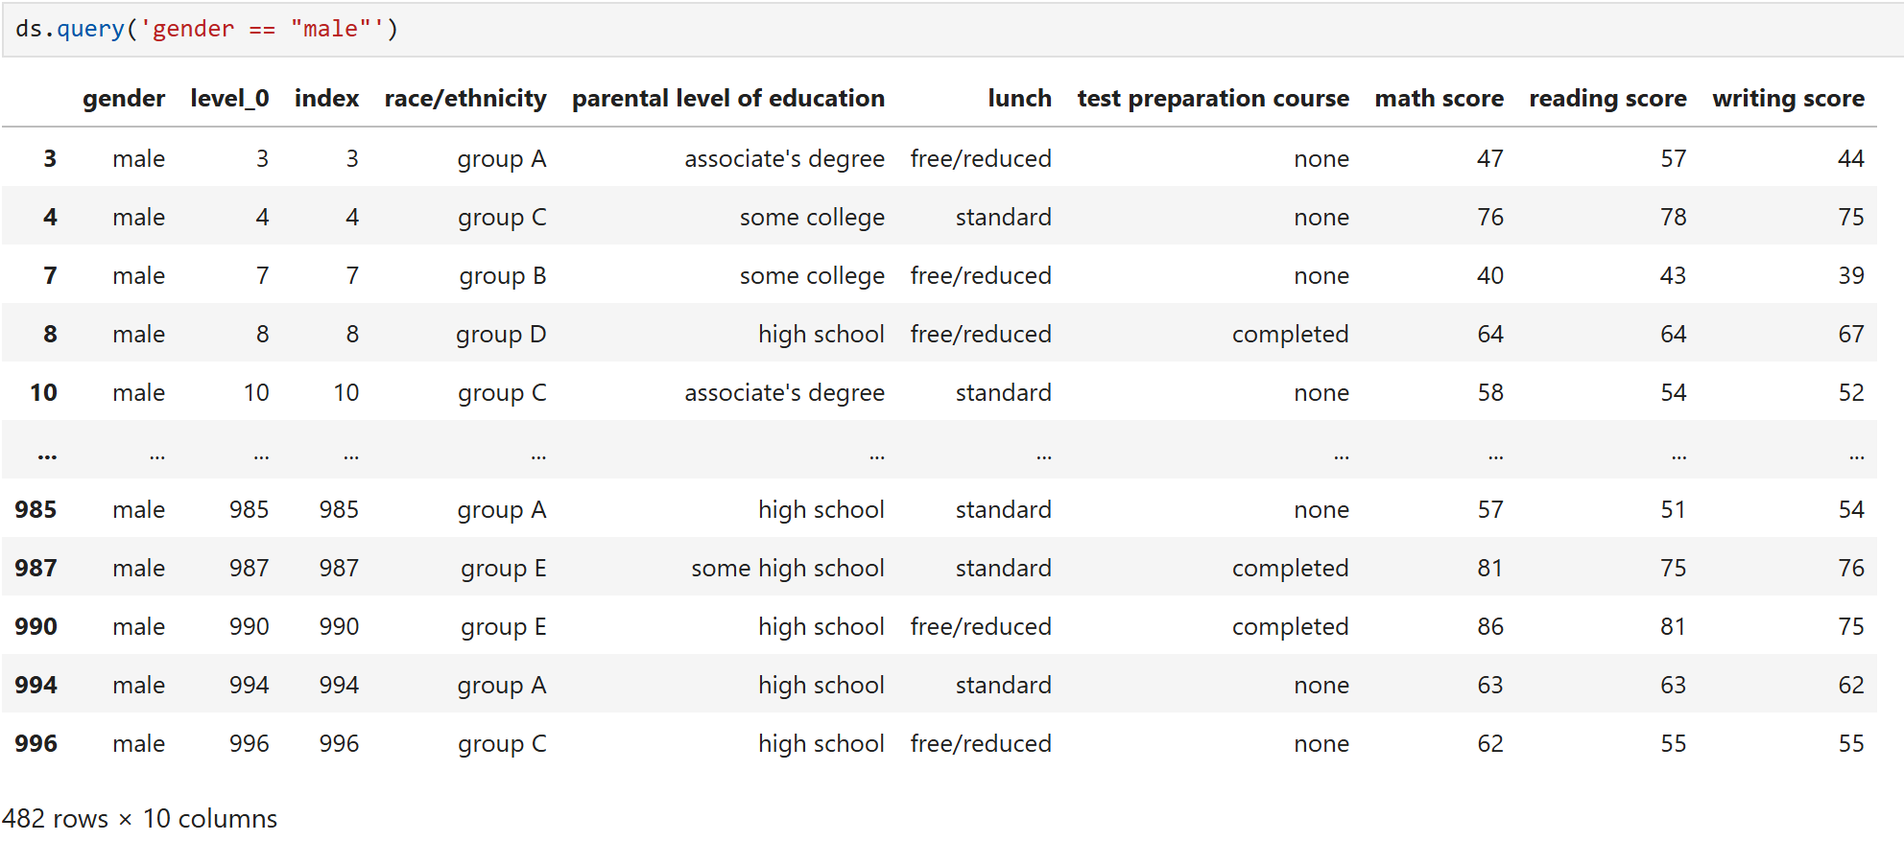

**Q.43.**

**=>** ds.query('gender == "male"')[['math score','reading score']]

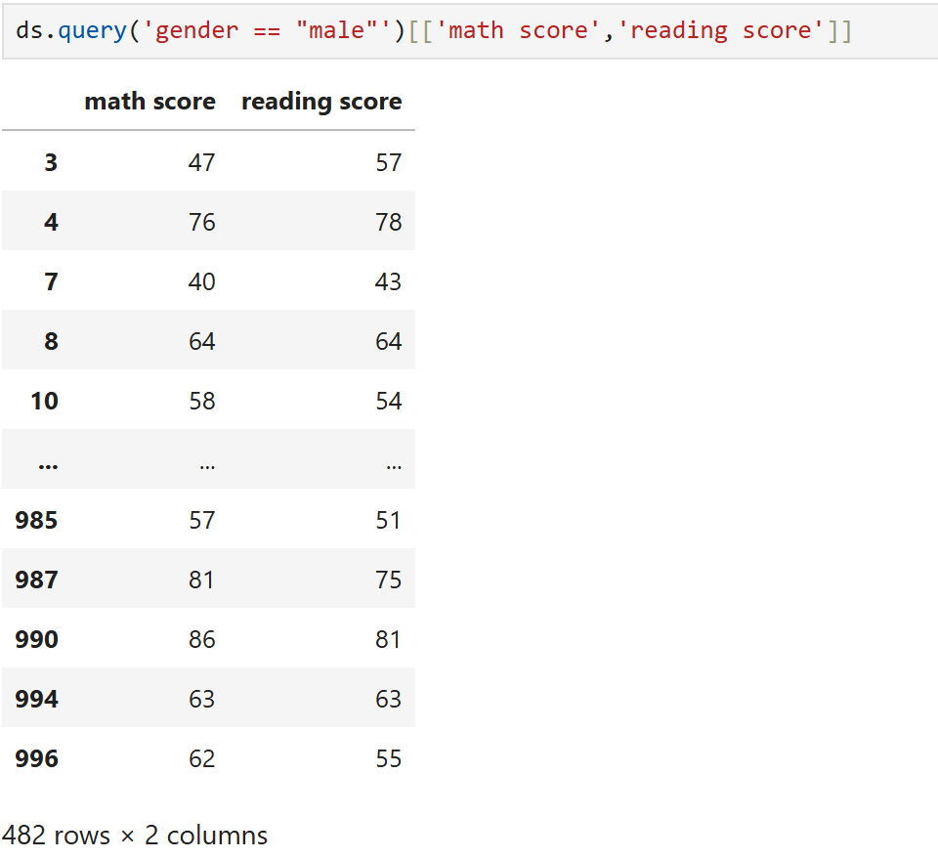

**Q.44.**

**=>** ds[(ds['race/ethnicity'] == "group A") & (ds['lunch'] == "free/reduced")][['writing score']]

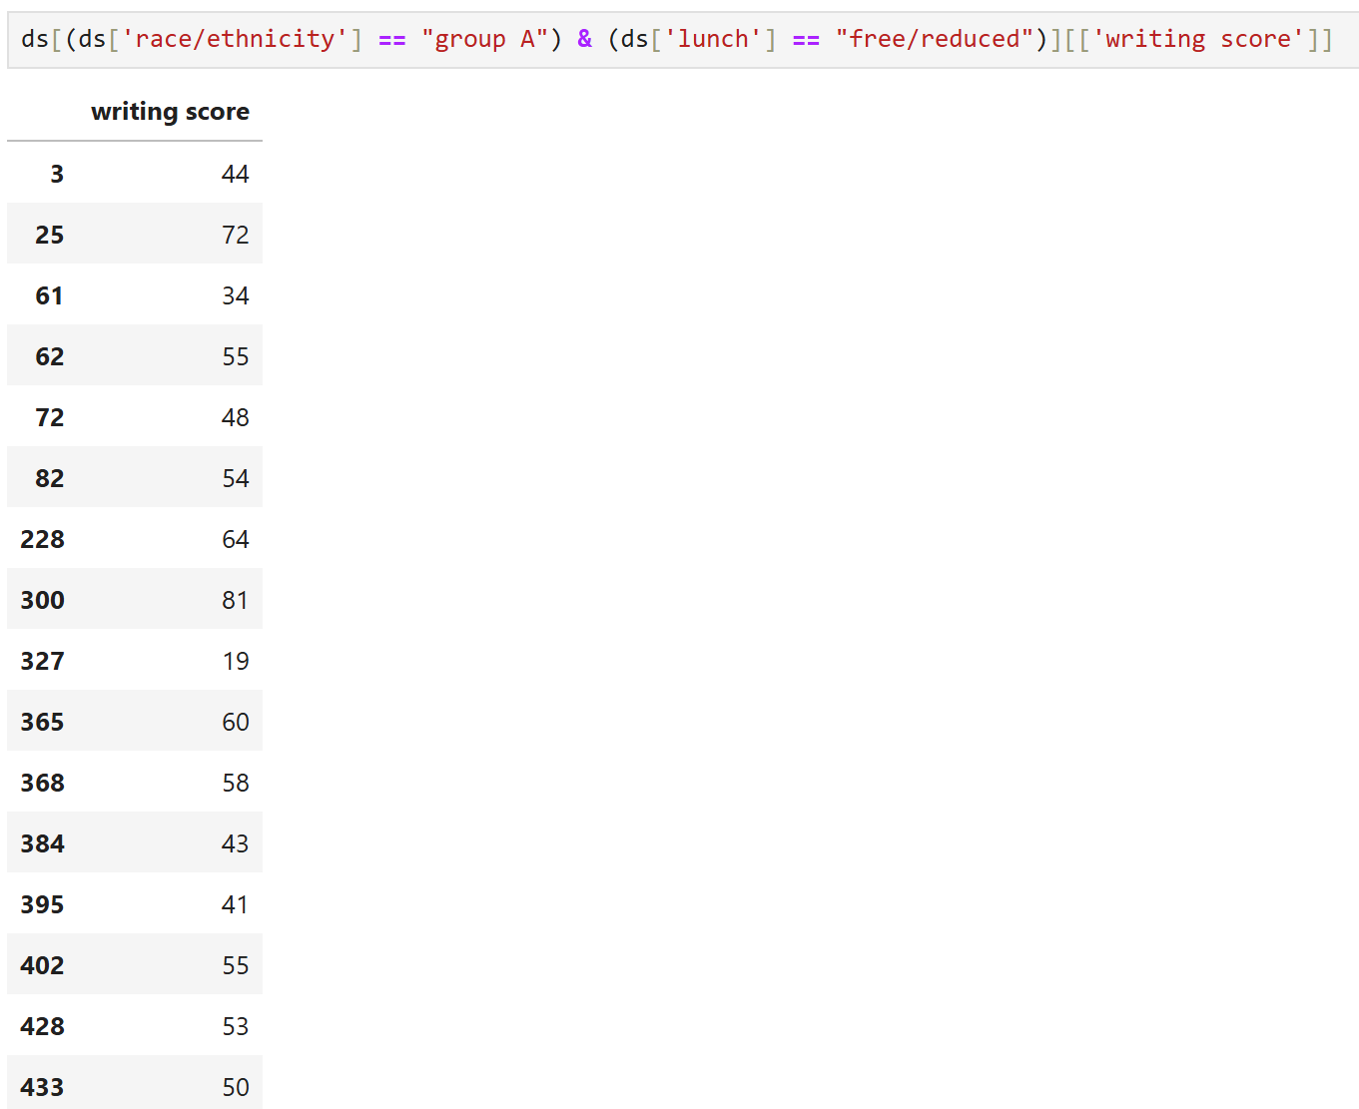

**Q.45.**

**=>** race_ethnicity = ['group A','group D']

filter = ds['race/ethnicity'].isin(race_ethnicity)

ds.loc[filter,'race/ethnicity']

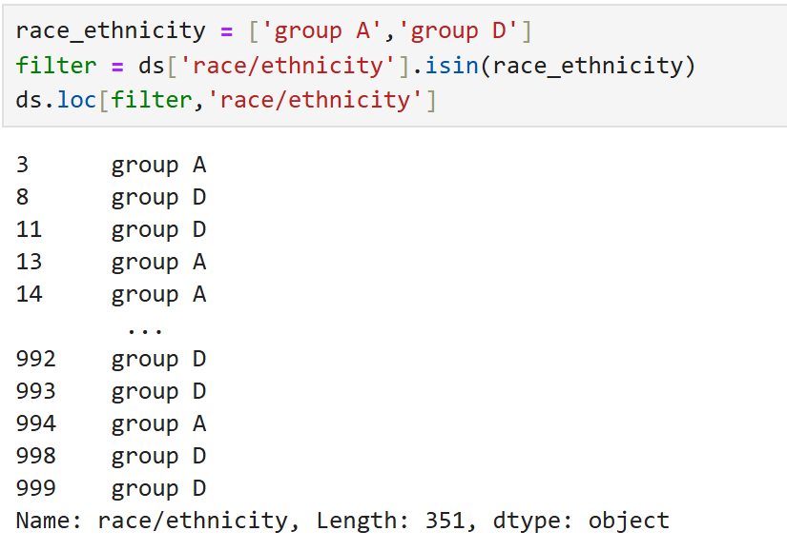

**Q.46.**

**=>** m= ds['parental level of education'].str.contains("associate's degree",na=False)

ds.loc[m,'parental level of education']

